Doc Ref. No: XXX/
Version No:
Doc Issue Date:

STANDARD OPERATING PROCEDURE
CORONAVIRUS AG RAPID TEST CASSETTE (SWAB)
TEST PROCEDURE

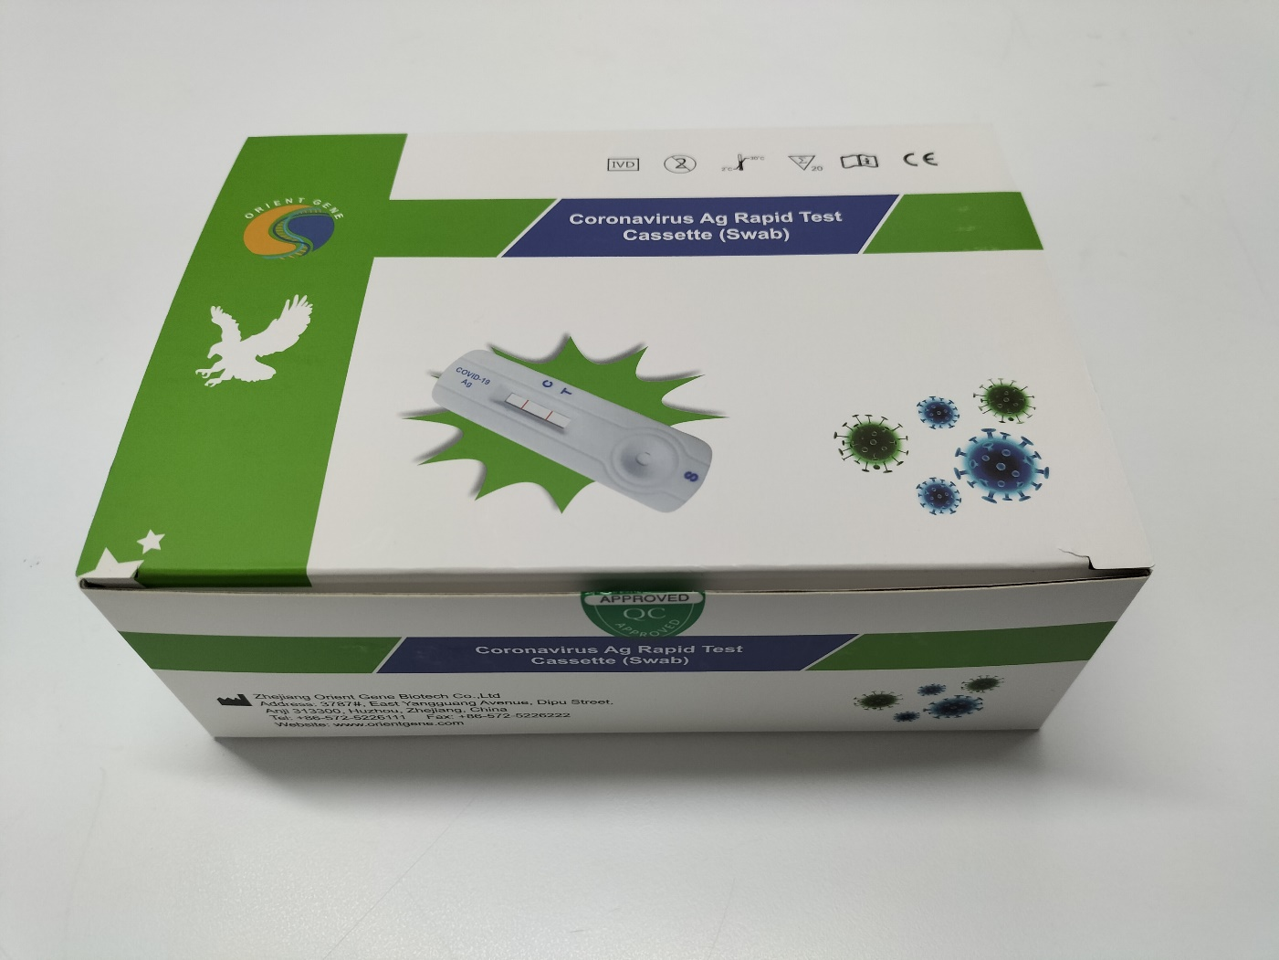
STANDARD OPERATING PROCEDURE
Pre – task requirements
You will need a timer/stopwatch and the tests
Standard Timings
Each test takes 16 minutes overall
Setup:
Tests to be at room temperature and comprise of the following:
Workstation | Extraction Tube | 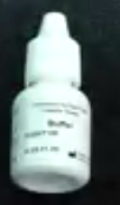  Buffer Vial |  | Test Cassette  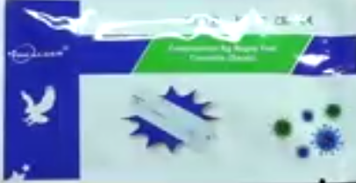
Sterile Swab |  |  | - Staff List and Pen  - PPE for person performing the test:  - Face shield  - Surgical Gloves  - Rubbish bin for used tests
Before use
Check the expiry date on the side of the carton and on the cassette packet.
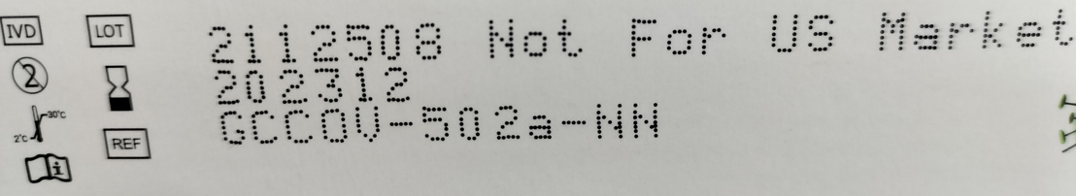
This date reads 2023 = year
12 = month

Write the lot number and expiry date on the top of your team list.
Top number is lot number

Testing Procedure: | Notes
Step 1:Insert the Extraction Tube and Buffer Vials into the workstation  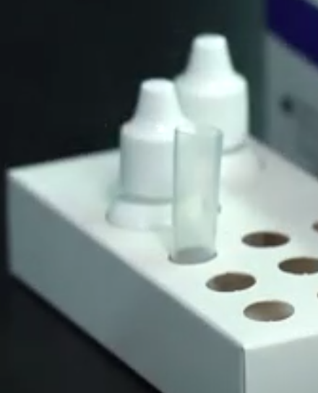 | Ensure the tube is standing firm and reaches the bottom of the workstation
Step 2: Add 10 drops of solution from the Buffer vial into the Extraction Tube
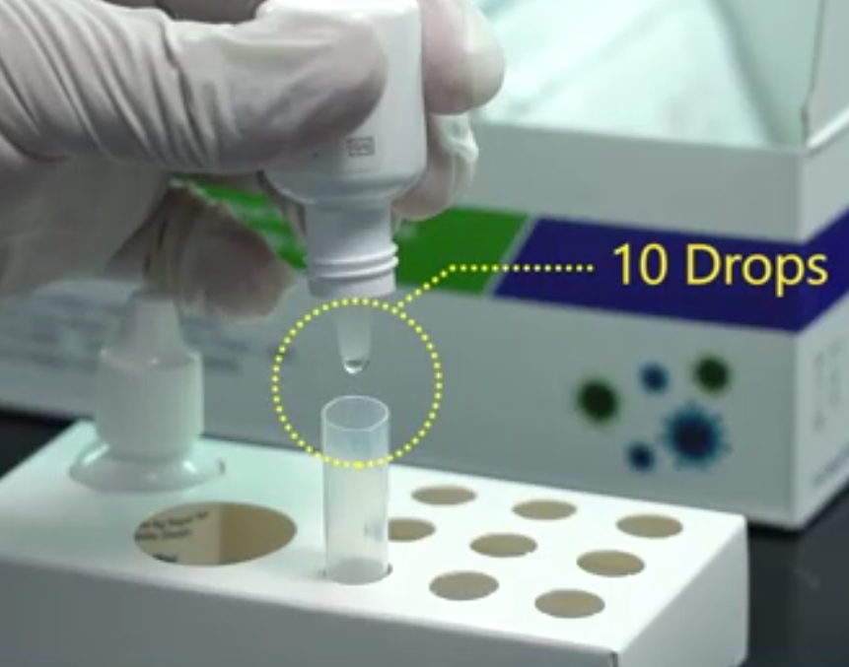
Step 3: Without touching the swab with your hands, remove the swab from the packaging by peeling the top of the plastic packet downwards.  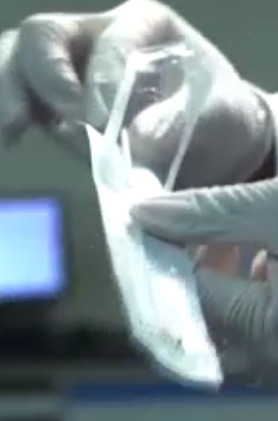 | Right end of swab?
Step 4:Carefully insert the swab into one nostril of the team member. Roll the swab 5 times against the lining of the nostril.  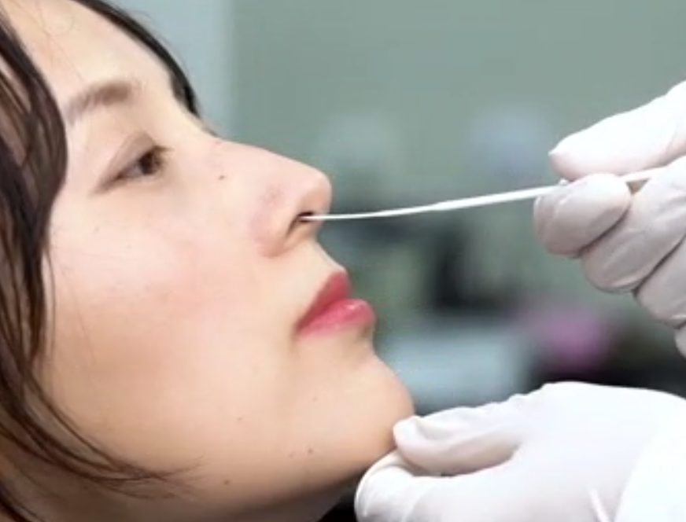 | The swab tip should be inserted between 2-4cm.  If the swab has blood or snot on it DO NOT USE.
Step 5:Using the same swab repeat Step 4 with the other nostril
Step 6:Withdraw the swab and place into the extraction tube
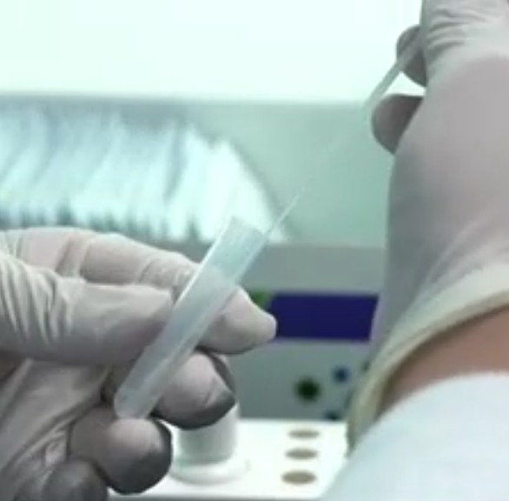
Step 7: Roll the swab at least 6 times while pressing the head against the bottom and side of the extraction tube
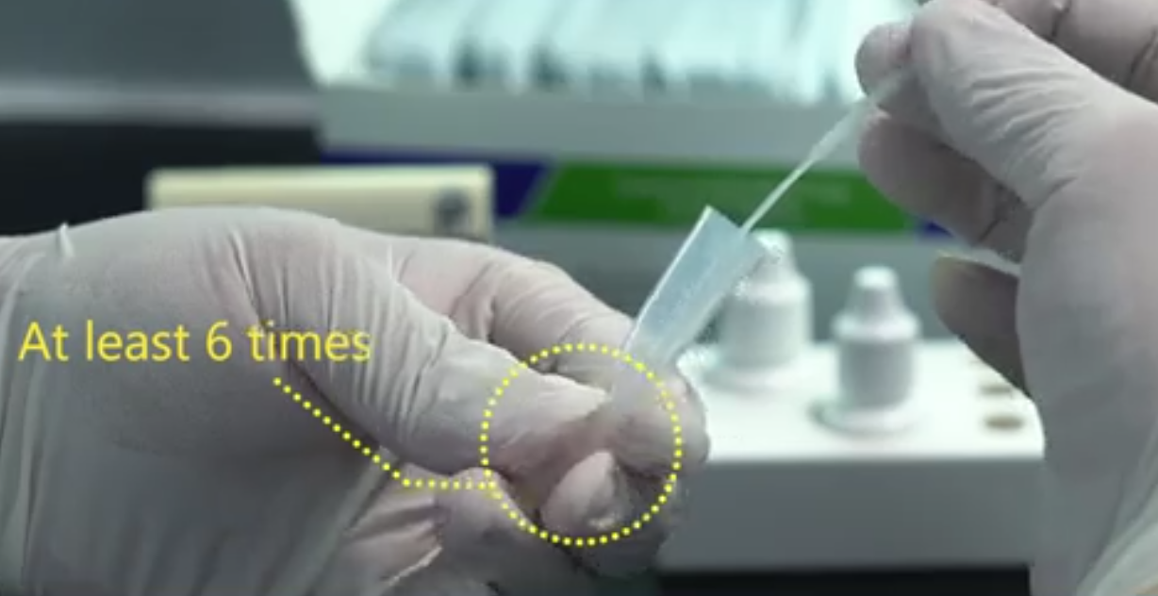
Step 8:Set your timer for 1 minute leaving the swab inside the extraction tube
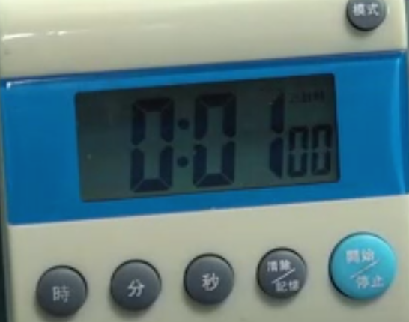
Step 9:After 1 minute, squeeze the tube several times from the outside to immerse the swab in the sample.
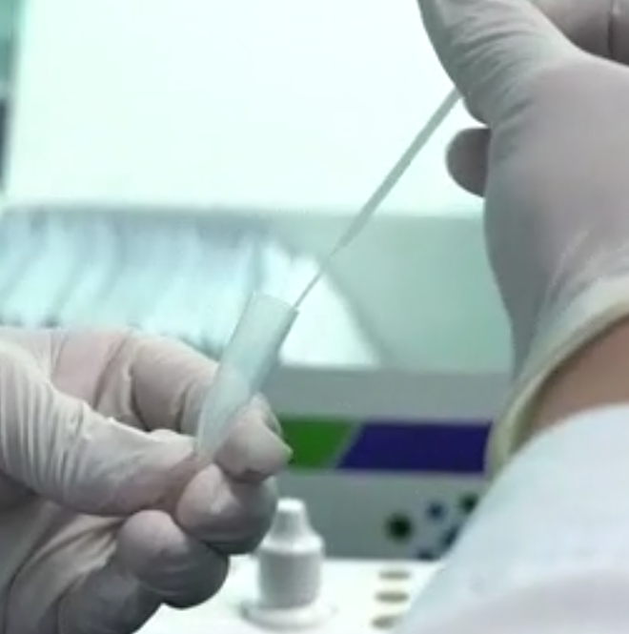
Step 10: Remove the swab from the tube and discard into the rubbish.
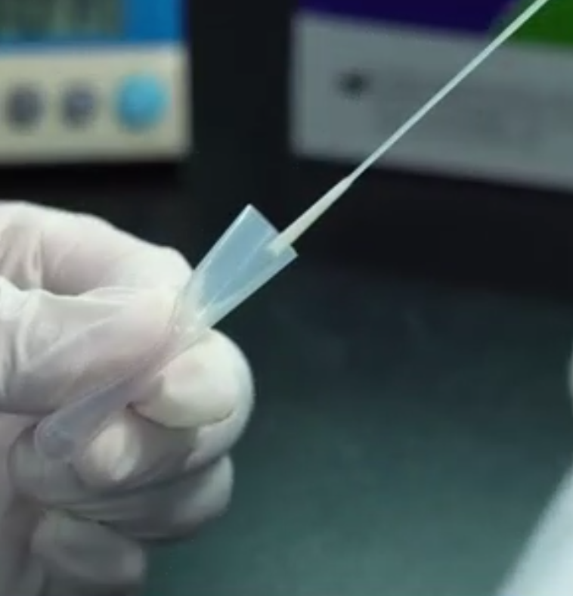
Step 11:Insert the dropper top/lid securely onto the top of the tube.
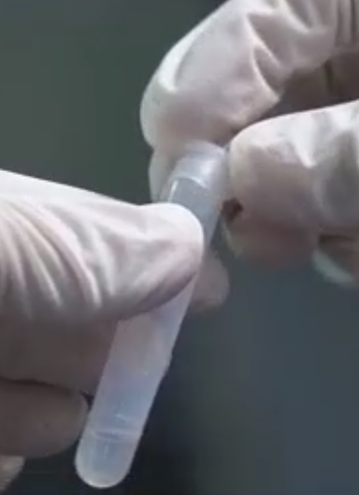
Step 12: Open the packet that contains the test cassette and place on a clean flat surface.  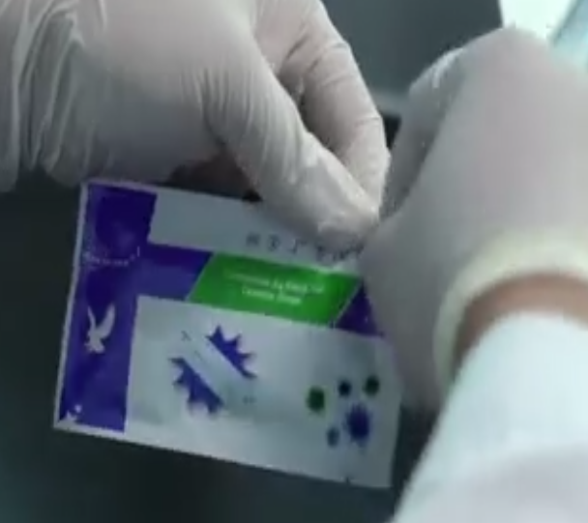 | Do not open until your sample is ready to be tested
Step 13: Hold the tube vertically and add 4 drops to the Sample Well (labelled S)
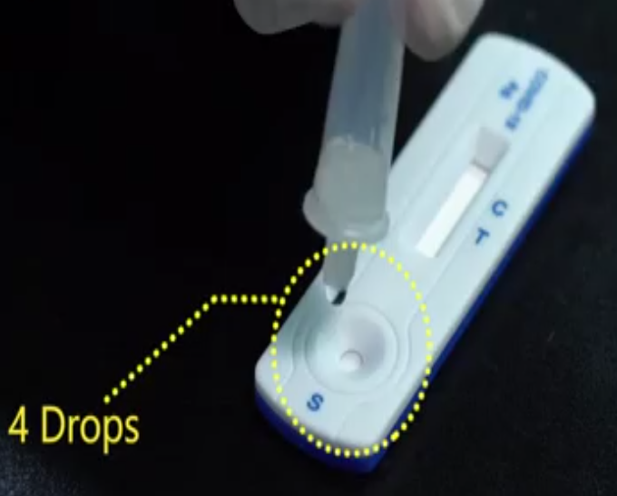
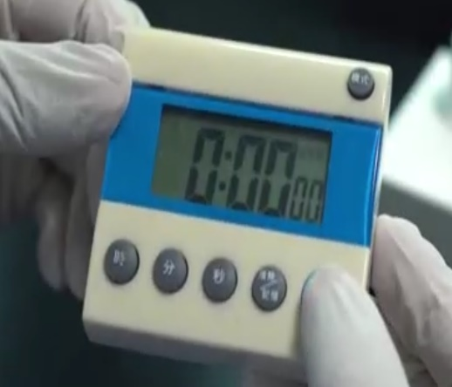
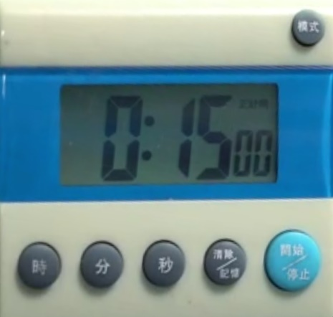
Step 14: Start the timer for 15 minutes.
Step 15: Important: Read the results of the test at 15 minutes (Do NOT interpret the results after 20 minutes. | If test result is past 20 minutes, the test will have to be redone.
POSITIVE RESULT – Presence of 2 lines C and T (even if faint)
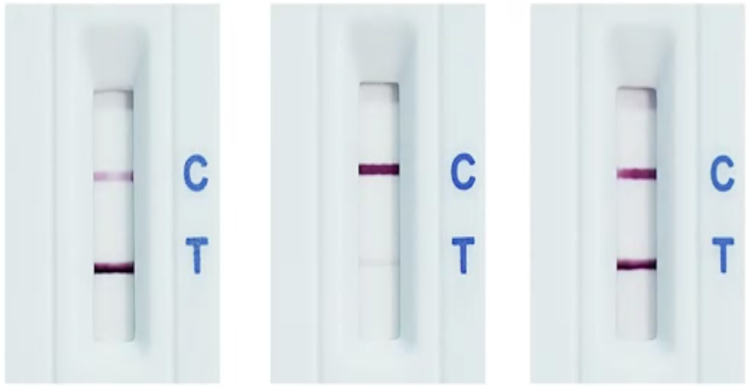
NEGATIVE RESULT – 1 single line adjacent to C
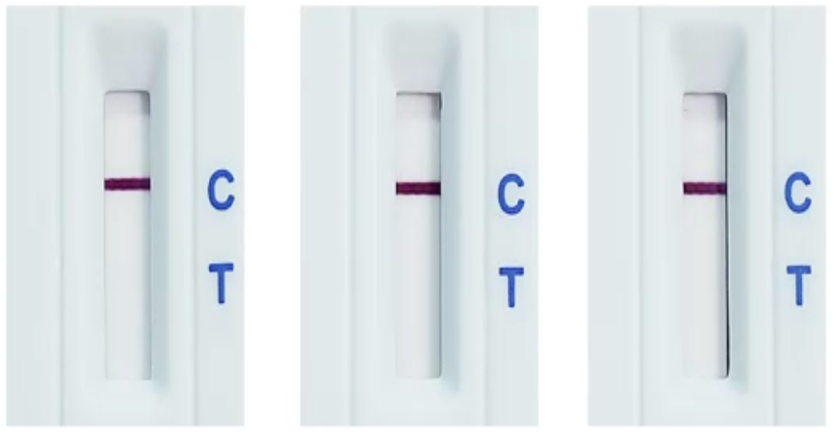
INVALID RESULT – 1 single line adjacent to T
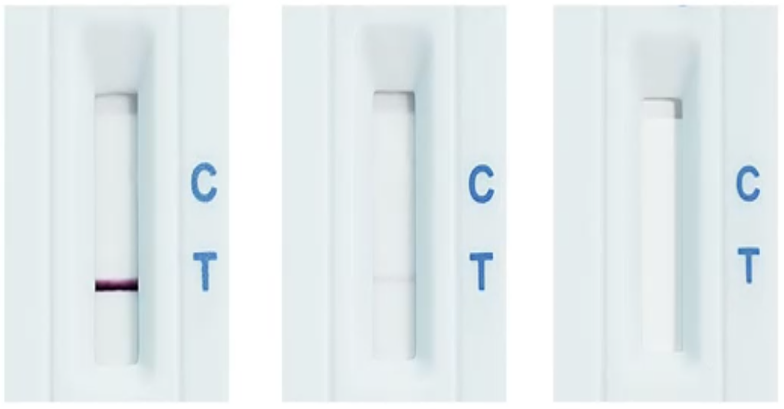
Step 16: Record each team members test result on the record sheet.

Amendment Register
New Version No. | Issue date / Review Date | Details of Amendment / Reviewed | Approved By
1 | 08.02.2022 | New Sop created. | Sheryl Guyton and Karyn Hitchcock

I have read the above sop for AG rapid test procedure and I’m happy with the contents. I believe this sop to be correct and is ready to be updated in the manuals.

Date | Name | Signature
 | Cameron Johnson
 | Maree Cleal
 | Mick Brown

