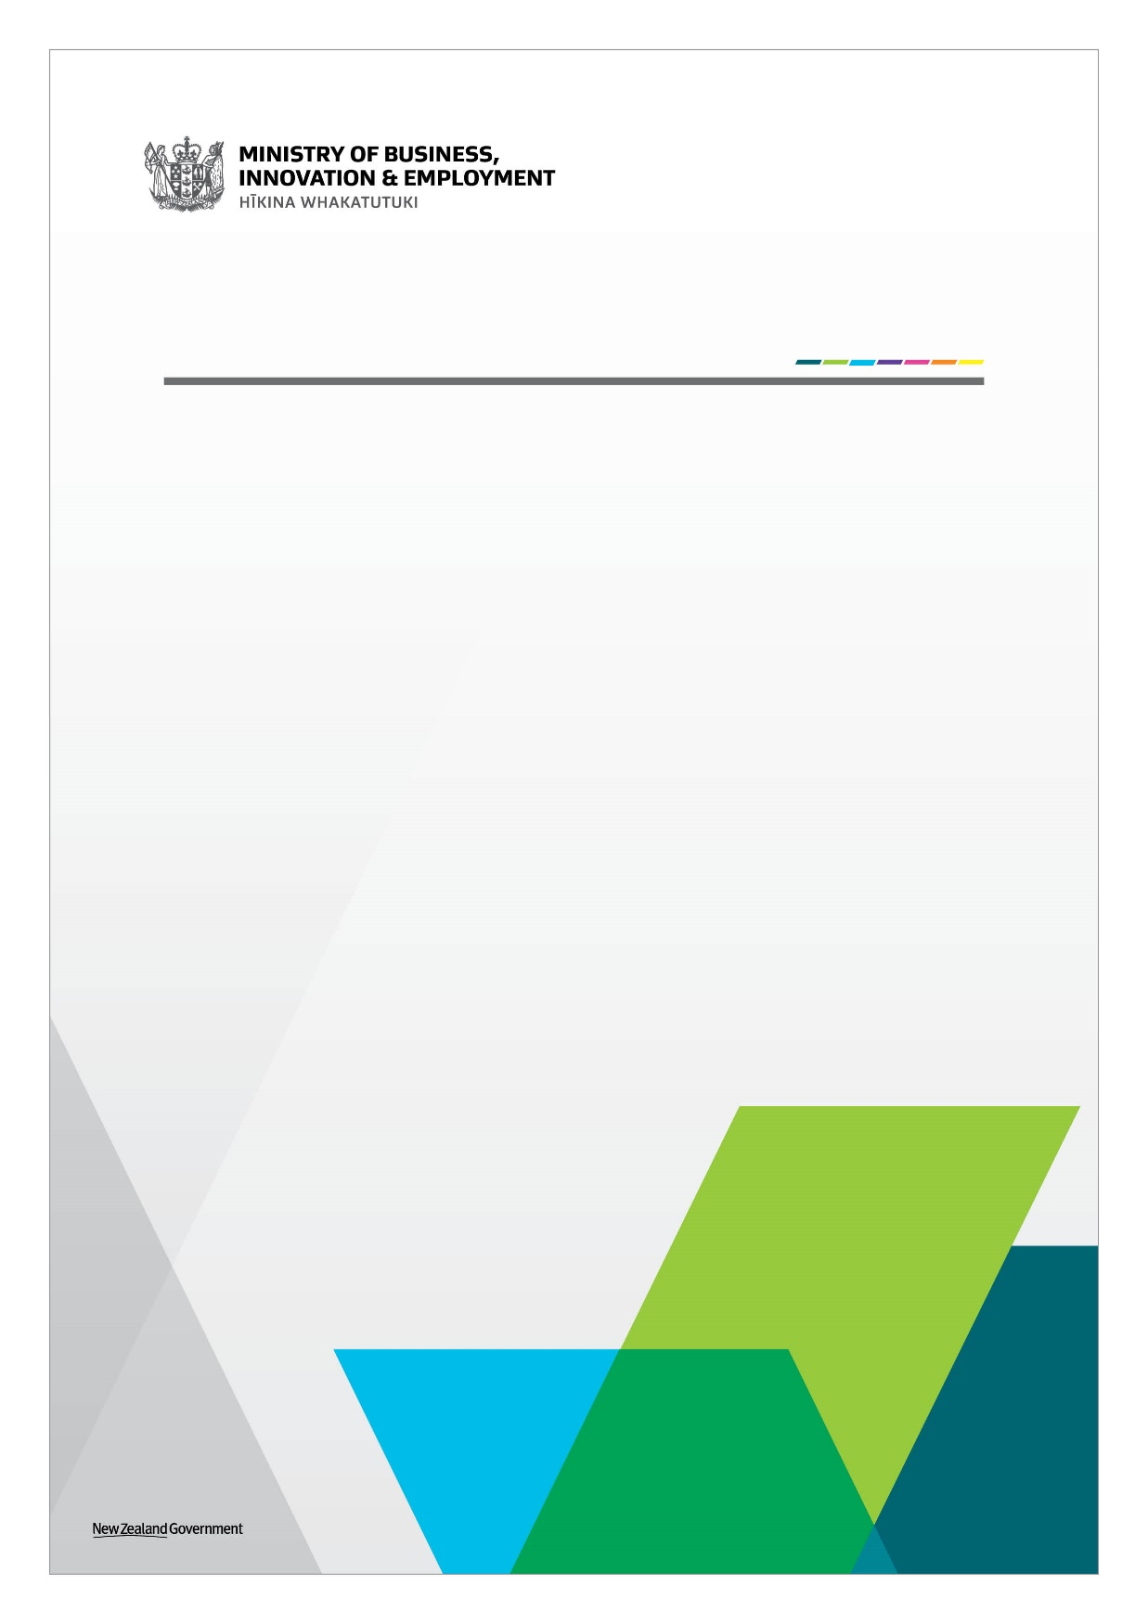
li
Tourism Communities: Support, Recovery and Re-set Plan

Tourism Kick-start Fund
Guide and Application Form
April 2022

Section 1: Information for Applicants
The Government has allocated additional funding to support tourism businesses through recovery from COVID-19 through the $200 million Tourism Communities: Support, Recovery and Re-set Plan (the Plan).
The Plan includes a $49 million Tourism Kick-start Fund to help prepare existing tourism businesses for the return of international visitors.
Tourism businesses can access funding through other initiatives in the Plan alongside the Tourism Kick-start Fund if required, including Business Advisory Support and the Business Advice Implementation Grant.
The organisations delivering the Business Advisory Support, Business Advice Implementation and Tourism Kick-start Fund initiatives are called Lead Entities. Lead Entities have local knowledge and expertise, and have been agreed with the five communities. These are:
- ChristchurchNZ (for Kaikōura and Mackenzie Districts)
- Great South (for Southland District)
- Queenstown Lakes District Council (for Queenstown Lakes District)
- Development West Coast (for Westland District).
Confidentiality: The application is confidential. Limited information may be published online by the Lead Entity and/or MBIE for accountability and transparency purposes. This is expected to be limited to the name of the business, location and grant amount approved except where subject to the Official Information Act 1982 or Local Government Official Information and Meetings Act 1987. The grant amount approved will be displayed as $10,000-$25,000 or $25,000-$50,000 to prevent the disclosure of commercially sensitive information.

Application process for the Tourism Kick-start Fund

* https://www.mbie.govt.nz/immigration-and-tourism/tourism/tourism-recovery/tourism-communities-support-recovery-and-re-set-plan/the-three-business-initiatives/
Eligibility Criteria
Your business must:
- Be a GST registered business, or GST registered prior to COVID-19 (either the 2018/19 OR 2019/20 financial year);
- Have a New Zealand Business Number (if you do not have a New Zealand Business Number, you can register here: https://www.nzbn.govt.nz/get-an-nzbn/);
- Be operating in a commercial environment;
- Be a privately‐owned business or Māori Trust or incorporation under the Te Ture Whenua Māori Act 1993 or similar organisation managing Māori assets under multiple ownership;
- Be a tourism business, which is defined as a business where at least 50 per cent of its operational output is purchased by tourists (domestic or international), for example: Accommodation, Arts and Recreational Services, Food Services, Transport Services or Retail Trade. This can include service businesses whose output is purchased by tourism businesses;
- Be physically based within at least one of the five communities: Queenstown Lakes District, Southland District, Kaikōura District, Mackenzie District, or Westland District (one grant per business operation);
- Have engaged in hibernation-like activities, for example: reduced opening hours, level of services, customers or business capacity due to COVID-19. Compared to either the 2018/19 OR 2019/20 financial year, a business must have experienced a drop in annual revenue (post-COVID) of at least 50 per cent;
- Have a minimum annual revenue of $60,000 pre-COVID-19 (either the 2018/19 OR 2019/20 financial year);
- Not have received direct Government tourism support from the Strategic Tourism Assets Protection Programme; and
- Pass a viability test demonstrating that the business will remain viable and operating up to and beyond the border re-opening. This can be discussed with one of your Lead Entity’s Growth Advisors.
Charitable Trusts, Incorporated Societies, Non-business entities, Local and Central Governments are ineligible.
Applications will be assessed on a case-by-case basis as they are received to enable businesses to apply when they are ready, help spread the workflows and for budget forecasting. The pace of this assessment will be dependent on the volume of applications received for the Tourism Kick-start Fund.
Grant conditions
The Tourism Kick-start Fund available for eligible businesses is between a minimum of $10,000 to a maximum of $50,000 per business operation (excluding GST). This grant is a contribution to increasing your level of service in preparation for the return of international visitors and should not be relied upon to sustain your business.
The grant will be calculated based on two weeks of pre-COVID-19 revenue set at two weeks of annual revenue for either the 2018/19 OR 2019/20 financial year.
- If your pre-COVID revenue was $60,000-$260,000, you would receive $10,000.
- If your pre-COVID revenue was more than $260,000, you would receive two weeks revenue up to a maximum of $50,000.
The Tourism Kick-start Fund provides one grant per business operation/site and that business operation/site needs to apply to the Lead Entity for the district they are physically based in.
Businesses with more than one site (i.e. as part of a chain) would only be eligible for the business operation/site that is physically based within the five communities, and each site must have separate audited financial accounts (or separate IR10 forms) to be assessed for this support. Where separate operations exist under a group structure or under one NZBN, the maximum grant available to that group would be $50,000. Please speak to your Growth Advisor for further guidance.
In Scope
The Tourism Kick-start Fund can be used for some or all of the following operational activities:
- Recruitment and wages for staff
- Training
- Operating expenditure (e.g. Restocking, certification, WOF, accounting software)
- Fixed overheads (e.g. office leases)
- Marketing
- Repairs and maintenance directly related to scaling up business operations.

Out of scope
Tourism Kick-start Funds cannot be used for:
- Capital expenditure (e.g. purchasing computer hardware, vehicles, boats, planes)
- Any other situation where an actual, perceived or potential conflict of interest may exist, without prior written approval from the Lead Entity
- Paying off debt your business has incurred.
Payment
Payments will be made by the Lead Entity to the business on satisfactory confirmation that any conditions of funding to manage successful outcomes have been met. Exact payments timeframes will be communicated by the Lead Entity for your district.
Reporting and accountability
The business that receives a grant must retain evidence of the expenditure for transparency and audit purposes. An audit may be conducted on grants given.
Grant recipients may be required to complete a survey for the Ministry of Business, Innovation & Employment to measure the outcomes of the Tourism Kick-start Fund (e.g. the level the business is operating and solvent, the level of operation compared to or closed).

Definitions
“Contracting Entity” refers to the business the application being completed for.
“Lead Entity” refers to the organisation(s) delivering the Tourism Kick-start Fund in the five communities. There are four Lead Entities.
“Applicant” refers to the individual(s) completing the application form on behalf of the business/ Contracting Entity.
Completing this form
If you need any assistance with completing this form, please contact the Lead Entity for your district highlighted here.
Please complete the form electronically, and attach the following:
☐ Your bank account details and third party verification (such as a bank statement or screenshot of your internet banking).
☐ Proof of GST registration (e.g. screenshot from MyIR accounts tab showing the word GST and your business name).
☐ Two years of annual financial accounts or IR10 forms (balance sheet, and profit and loss statements) for your pre-COVID year, either 2018/19 or 2019/20, AND your post-COVID year, either 2020/21 or 2021/22.
☐ Evidence that the business has sufficient working capital and/or access to credit (e.g. Recent Bank statement, overdraft facility).
Submit your completed application to the Lead Entity for your district.
Proposal checklist
Before you apply be sure to complete the following:
☐ Read the supporting information on the MBIE website here and Lead Entity website here.
When filling out this form please ensure:
☐ All answers are typed into the space provided for each section in font no smaller than size 10 point.
☐ You provide the information required for each question.
☐ You have read and understood the declaration details outlined in Section 5 and have signed the declaration.
Evidence
When the Lead Entity assesses proposals against the criteria, they will consider whether the evidence provided supports the claims, as well as the quality of that evidence. Where questions ask for evidence to support claims, it is highly recommended that you provide reference sources that attest the accuracy and quality of the evidence.
The Lead Entity will assess the application using the information provided by the Applicant. In some cases, the Lead Entity may use a third party to assist with verification of decisions.

Section 2: Key details
Please enter answers in the right-hand column.
2.1 Key details
Business legal name (Contracting Entity):
Business trading name:
Physical business address, including postcode:
Business website:
GST registration number:
Please attach proof of GST registration
New Zealand Business Number:
Key point of contact (delegated by Business owner/s):
Email address:
Telephone:

Section 3: Eligibility
Please read this section carefully
The Tourism Kick-start Fund intends to boost existing tourism businesses out of reduced service once international visitors return by providing two weeks of pre-COVID-19 revenue set at two weeks of annual revenue for either the 2018/19 OR 2019/20 financial year. The grant is available to eligible businesses in Queenstown Lakes District, Southland District, Kaikōura District, Mackenzie District and Westland District.
Your business must meet all of the eligibility criteria to qualify for the Tourism Kick-start Fund.

3.1 Key eligibility criteria
1: Is the business a tourism business?  For the purposes of this Fund, the definition of a tourism business is:  A business where at least 50 per cent of its operational output is purchased by tourists (domestic or international), for example: Accommodation, Arts and Recreational Services, Food Services, Transport Services or Retail Trade. This can include service businesses whose output is purchased by tourism businesses. | Tourism Business: You must be a Tourism characteristic business:  - Was at least 50 per cent of the operations’ output purchased by visitors (domestic or international) prior to COVID-19? This can include service businesses whose output is purchased by tourism businesses.  Yes ☐ No ☐  Tourism characteristic – Identify the characteristic of your business as defined in the Businesses Demography Statistics, 2019:  - Accommodation ☐  - Arts and Recreational Services (e.g. activities and attractions) ☐  - Food Services ☐  - Transport Services ☐  - Retail Trade ☐  - Other (please specify) Click or tap here to enter text.
2: Is the business physically based within at least one of the five communities?  Businesses with more than one site (i.e. as part of a chain) would only be eligible for the business operation/site that is physically based within the five communities.  Further guidance is available under ‘Grant Conditions’ (Section 1). | Business location: Your business must be physically located within the geographical boundaries of one (or more) of the following five communities:  - Queenstown Lakes District ☐  - Southland District ☐  - Westland District ☐  - Mackenzie District ☐  - Kaikōura District ☐  Are you applying for the Tourism Kick-start Fund for a business operation in another eligible district?  Yes ☐ No ☐  If yes, please specify Click or tap here to enter text.
3: Has the business experienced a drop in annual revenue of at least 50 per cent compared to either the 2018/19 OR 2019/20 financial year?  Hibernation-like activities will be measured as a business that has seen a drop in revenue of at least 50 per cent from either 2018/19 OR 2019/20 to either 2020/21 OR 2021/22 financial year. | Hibernation-like activities is a reduction in the provision of services or products. Has your business experienced a drop in annual revenue of at least 50 per cent compared to either the 2018/19 OR 2019/20 financial year?  Yes ☐ No ☐  Please attach financial accounts (or IR10 forms) for your pre-COVID year, either 2018/19 or 2019/20, AND your post-COVID year, either 2020/21 or 2021/22, (balance sheet, and profit and loss statements) as evidence to determine eligibility and the grant value – e.g. two weeks of pre-COVID-19 revenue.  Note: Revenue is defined as “the total amount of money a business has earned from its normal business activities, before expenses are deducted", and shouldn't include the Wage Subsidy or any other government assistance payments.
4. Has the business previously received direct Government tourism support?  Businesses that have previously received direct Government support from the Strategic Tourism Assets Protection Programme are not eligible for the Tourism Kick-start Fund. | Has your business received direct Government tourism support from the Strategic Tourism Assets Protection Programme?  Yes ☐ No ☐  If yes, you are not eligible for the Tourism Kick-start Fund.  Note: Businesses that received the Wage Subsidy or other Government support are eligible for the Tourism Kick-start Fund.

Section 4: Business situation
4.1 What is your tourism business?
In this section, we want to understand a summary of your business, current situation and the future outlook.
Please provide a brief description of:  - the purpose of your business and its commercial nature  - the percentage of the operations’ output purchased by visitors (domestic or international) prior to COVID-19  - impacts of COVID-19  - action taken to manage those impacts  - future outlook for your business.  This can include service businesses whose output is purchased by tourism businesses. | Word limit of 400

4.2 Current business situation
In this section, we want to understand your current situation and how it has been impacted by COVID-19.
Please describe how you have adapted your business to hibernate or continue trading at a reduced level of service since COVID-19?  For example:  - changing prices  - adapting to the domestic market  - reduced hours of operation  - additional borrowing from the private market (e.g. your bank). | Word limit of 400
What percentage of operation would you consider you are operating at compared to prior to COVID-19?
e.g. 25 per cent operation compared to prior to COVID-19.

4.3 Future Outlook
In this section, we want to understand your future outlook, business viability and when you intend to increase the provision of services or products.
What is the current outlook for your business?  If possible, you may wish to:  - demonstrate demand for your products and services  - describe what new markets have emerged.  Please include supporting evidence such as forward bookings, accommodation bookings, and travel forecasts. | Word limit of 200
Timing – When do you expect to increase your service level to respond to higher visitor demand? | Please select a date below.  Click or tap to enter a date.
Timing of payment – In preparation for increased service level, when should the funding be released to you?  e.g. For a business focused on the summer season, we would anticipate two months to prepare prior to the increased demand. | Please select a date below.  Click or tap to enter a date.
What information have you used to base the date on (e.g. Forward bookings, forecasts)? | Word limit of 200
Viability - Have you secured funding from other sources (e.g. banks, investors)?  This grant is a contribution to increasing your level of service and should not be relied upon to sustain your business. | Yes ☐ No ☐  If yes, how much? Click or tap here to enter text.
Viability - Do you have sufficient cash, overdraft facilities or access to other funding to pay your core business expenses for three months?  Working capital should cover the minimum operating costs. | Yes ☐ No ☐  If yes, how much? Click or tap here to enter text.
Viability - How confident are you that with this grant your business will continue for at least three months?  If you are not confident, talk to your Growth Advisor about alternative support available. | Please choose an item from the drop-down menu below.  Choose an item.

4.4 Intended use of Tourism Kick-start Fund
In this section, we want to understand what your grant would be used for.

Please provide a breakdown of how you intend to spend the grant. In your answer, please cover:  - Recruitment and wages for staff  - Training  - Operating expenditure (e.g. Restocking, certification, WOF, accounting software)  - Fixed overheads (e.g. office leases)  - Marketing  - Repairs and maintenance directly related to scaling up business operations  Capital expenditure is ineligible. | Word limit of 400

Section 5: Declaration by Applicant
- The Contracting Entity is compliant and will continue to comply with all applicable laws, regulations, rules and professional codes of conduct or practice including but not limited to health and safety and employment practices
Yes: ☐ No: ☐
- The Contracting Entity is operating in a commercial environment.
Yes: ☐ No: ☐
- The Contracting Entity is a privately‐owned business or Māori Trust or incorporation under the Te Ture Whenua Māori Act 1993 or similar organisation managing Māori assets under multiple ownership.
Yes: ☐ No: ☐
- The Contracting Entity does not expect, nor does it intend to, wind up the business or cease operating within three months of submitting this application.
Yes, it does: ☐ No, it does not: ☐

- Has the Applicant or the Contracting Entity ever been insolvent or subject to an insolvency action, administration or other legal proceedings?
Yes: ☐ No: ☐
- Has any individual in the Applicant’s team (including the Applicant’s Leadership Team, directors, partners, or trustees, or any key members of the project) ever been insolvent or subject to an insolvency action, administration or other legal proceedings, or actively involved in any organisation which has?

Yes: ☐ No: ☐
- Has any individual in the Applicant’s team (including the Applicant’s Leadership Team, directors, partners, or trustees, or any key members of the project) ever been adjudged bankrupt or is an undischarged bankrupt?

Yes: ☐ No: ☐
- Has any individual in the Applicant’s team (including the Applicant’s Leadership Team, directors, partners, or trustees, or any key members of the project) ever been under investigation for, or been convicted of, any criminal offence?

Yes: ☐ No: ☐
- Are there any actual, potential or perceived conflicts of interest that the Applicant or any of the key personnel have in relation to this project? For example, if the Growth Advisor is related to the business owner(s), this would be a conflict of interest. This may not be an issue, as the business owner(s) can work with an alternative Growth Advisor.
Yes: ☐ No: ☐
If you answered “Yes” to questions 4-9, please provide a description below:

By completing the details below, the Applicant makes the following declarations about its application to the Tourism Kick-start Fund (“application”):
☐ The statements in the application are true and the information provided is complete and correct, and there have been no misleading statements or omissions of any relevant facts nor any misrepresentations made;
☐ I have secured all appropriate authorisations to submit the application, to make the statements and to provide the information in the application;
☐ I have obtained the permission of my business owner(s) to provide the information contained in this application and those individuals are aware of, and agree to, the Terms and Conditions of applying for the Tourism Kick-start Fund;
☐ I understand that the application may be subject to the Local Government Official Information and Meetings Act 1987 (LOGIMA) and/or the Official Information Act 1982 (the OIA). The LOGIMA and OIA may enable information to be withheld under certain conditions;
☐ I have no actual, potential or perceived conflict of interest (except any already declared in the application) in submitting the application, or entering into a contract. Where a conflict of interest arises during the application or assessment process, I will report it immediately to the Lead Entity by email;
☐ I understand that the falsification of information, supplying misleading information, or the suppression of material information in this application, may result in the application being eliminated from the assessment process and may be grounds for termination of any contract awarded as a result of this application process; and
☐ I consent to the Lead Entity undertaking due diligence including any third party checks as may be required to fully assess the application.

Signature
This acknowledgment must be signed by a person with the legal authority to commit the Contracting Entity to a transaction (e.g. Chief Executive)
Name
Title
Organisation

Signature

Date | Click or tap to enter a date.

Section 6: Attachments
Please attach evidence of:
- Your bank account details and third party verification (such as a bank statement or screenshot of your internet banking);
- Proof of GST registration (e.g. screenshot from MyIR accounts tab showing the word GST and your business name);
- Two years of annual financial accounts or IR10 forms (balance sheet, and profit and loss statements) for your pre-COVID year, either 2018/19 or 2019/20, AND your post-COVID year, either 2020/21 or 2021/22 financial years as evidence to determine eligibility and grant value;
- Sufficient working capital to scale up to continue to be a viable business; and
- Any additional information you consider necessary to support your application. Note that there is a 20MB size limit. For larger applications, please separate them into different emails.

