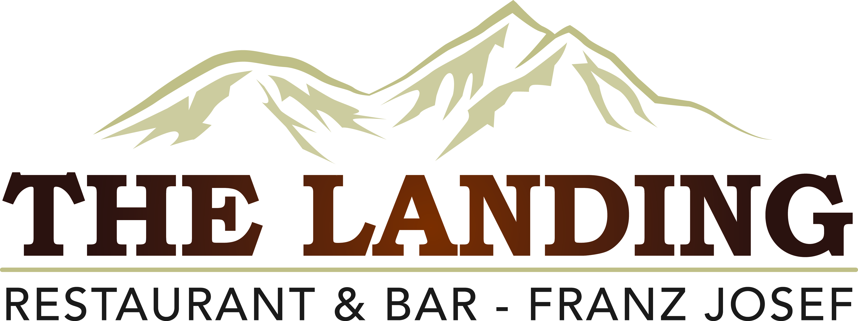
TWO COURSE MENU
MAINS
The Big "L" Cheese Burger** (Also can be Vegetarian Burger)
The Landing Classic cheeseburger packed with, tomato, lettuce, Beef Pattie, onion & cheese served with Landing fries.

Chicken Parmigiana
Chicken Breast lightly crumbed then fried till golden topped with tomato,
sauce, cheese and finished off with plum sauce, served Landing fries.

Old Time Roast Pork Belly**
Served with gourmet potatoes, seasonal vegetables, pork crackling, homemade apple sauce & Landing Jus.

Traditional Bangers and Mash **
Prime West Coast sausages served on rich creamy mash, seasonal vegetables and
topped with Landing Jus.

Lamb shank**
Slow braised New Zealand Lamb shank, served with rich creamy mash, seasonal vegetables & Landing Jus.

Coast to Coast Fish & Chips
Southern Blue Whiting dipped in a Summit lager beer batter makes this fish & chips something to remember; served with lemon, salad greens and tartare sauce

Creamy Pesto Pasta (Vegetarian)
Pasta Tossed With Onion, Capsicum and creamy pesto sauce and topped with Parmesan Cheese.

Vegetable Salad **
Salad greens, sundried tomatoes, feta, olives, capsicum, roasted kumara, Onion tossed with homemade honey mustard dressing

DESSERT
Choc a lot
Warmed double chocolate torte, served with whipped cream, Double chocolate ice cream, whipped cream and rich Chocolate sauce
Kiwiana*
Pavlova topped with kiwifruit, served with Hokey Pokey ice cream and freshly whipped cream.

(ITEMS WITH (*) ARE GLUTEN FREE OR CAN BE DONE GLUTEN FREE)
PRICE PER PERSON
$42.50 PER ADULT
FREE OF CHARGE POLICY
1 FOC PER15 Paying Customers
2 FOC’s PER 30 Paying Customers

1st October 2023 - 1st October 2024

