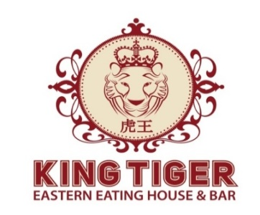

October 2023 – October 2024 PRICE LIST
INDIAN DINNER SET MENU
VEGETARIAN  - Spring Rolls Or Veg Pakoras or Veg. Soup  - Dal Makhani or Dal Tadka  - Paneer Butter Masala or Shahi Paneer  - Naan / Roti  - Kadai Vegetable or Mixed Veg Curry  - Condiments  - Ice cream or Rice Kheer  $40.50 – ADULT (MIN 10 PAX)  $21.50 – CHILD (3-12YEARS)  $0.00 – INFANT (0-3 YEARS) | NON VEGETARIAN  - Spring Rolls or Veg Pakoras or Veg. Soup  - Butter or Kadai or Vindaloo Chicken  - Naan / Roti  - Dal Makhani or Dal Tadka  - Kadai Vegetable or Mixed Veg Curry  - Paneer Butter Masala or Shahi Paneer  - Condiments  - Ice Cream or Rice Kheer  $40.50 – ADULT (MIN 10 PAX)  $21.50 – CHILD (3-12YEARS)  $0.00 – INFANT (0-3 YEARS)

FREE OF CHARGE POLICY:
15 PAYING CUSTOBERS – 1 FOC
30 PAYING CUSTOMERS – 2 FOC

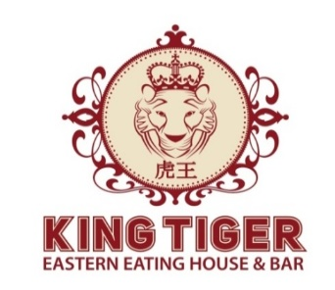

OCTOBER 2023 – OCTOBER 2024 PRICE LIST

INDIAN SET LUNCH MENU
VEGETARIAN SET LUNCH  - Dal Makhani or Dal Tadka  - Butter Nan or Tandoori Roti or Plain Naan  - Kadai Vegetable or Mixed Vegetable Curry  or Aloo Mutter  - Steamed Rice  - Condiments  - Ice Cream or Rice Kheer  $28.75 – ADULT  $19.50 – CHILD (3-12YEARS)  $0.00 – INFANT (0-3 YEARS) | NON VEGETARIAN SET LUNCH  - Butter or Kadai or Vindaloo or Tikka Massala  with chicken  - Butter Naan or Tandoori Roti or Plain Naan  - Dal Makhani or Dal Tadka  - Steamed Rice  - Condiments  - Ice Cream or Rice Kheer  $28.75 – ADULT  $19.50 – CHILD (3-12YEARS)  $0.00 – INFANT (0-3 YEARS)

FREE OF CHARGE POLICY:
15 PAYING CUSTOMERS – 1 FOC
30 PAYING CUSTOMERS – 2 FOC

*Please call in advance for any appropriate changes in menu*
*The menus can be changed according to periodic addition or subtraction of dishes from main restaurant menu*
*Please notify to smaller groups travelling without tour guides to bring dinner vouchers*

